**Management Principles for Engineers**

***Lecture Notes***



***Compiled By:***

**Career Development Centre**

**SRM IST**

# UNIT I

UNIT I

**Henry Fayol’s Principles of Management**

One of the oldest and most popular approaches, Henry Fayol’s theory holds that administration of all organizations – whether public or private, large or small – requires the same rational process or functions.

This school of thought is based on two assumptions −

* Although the objective of an organization may differ (for example, business, government, education, or religion), yet there is a core management process that remains the same for all institutions.
* Successful managers, therefore, are interchangeable among organizations of differing purposes. The universal management process can be reduced to a set of separate functions and related principles.

Fayol identifies fourteen universal principles of management, which are aimed at showing managers how to carry out their functional duties.

|  |  |  |
| --- | --- | --- |
| **S.No** | **Universal principles of management** | **Managers Functional Duties** |
| 1 | Specialization of labor | This improves the efficiency of labor through specialization, reducing labor time and increasing skill development. |
| 2 | Authority | This is the right to give orders which always carry responsibility commensurate with its privileges. |
| 3 | Discipline | It relies on respect for the rules, policies, and agreements that govern an organization. Fayol ordains that discipline requires good superiors at all levels. |
| 4 | Unity of command | This means that subordinates should receive orders from one superior only, thus avoiding confusion and conflict. |
| 5 | Unity of direction | This means that there should be unity in the directions given by a boss to his subordinates. There should not be any conflict in the directions given by a boss. |
| 6 | Subordination of individual interest to common good | According to this principle, the needs of individuals and groups within an organization should not take precedence over the needs of the organization as a whole. |
| 7 | Remuneration | Wages should be equitable and satisfactory to employees and superiors. |
| 8 | Centralization | Levels at which decisions are to be made should depend on the specific situation, no level of centralization or decentralization is ideal for all situations. |
| 9 | Scale of chain | The relationship among all levels in the organizational hierarchy and exact lines of authority should be unmistakably clear and usually followed at all times, excepting special circumstances when some departure might be necessary. |
| 10 | Order | There should be a place for everything, and everything should be in its place. This is essentially a principle of organization in the arrangement of things and people. |
| 11 | Equity | Employees should be treated equitably in order to elicit loyalty and devotion from personnel. |
| 12 | Personal tenure | Views unnecessary turnover to be both the cause and the effect of bad management; Fayol points out its danger and costs. |
| 13 | Initiative | Subordinates should be encouraged to conceive and carryout ideas. |
| 14 | Esprit de corps | Team work, a sense of unity and togetherness, should be fostered and maintained. |

## 1.6. Environmental Factors- Internal and External Factors

Major elements of an organisation’s general environment

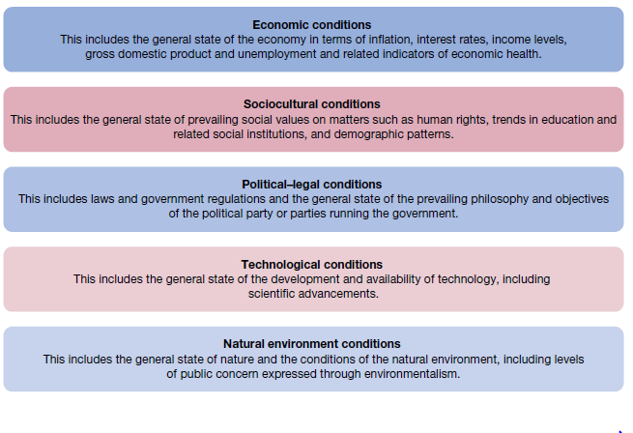

**Fig 1.6.1 Major elements of an organisation’s general environment**

**The specific environment**

The **specific environment** consists of the actual organisations, groups and people with whom an organisation interacts and conducts business. These are environmental elements of direct consequence to the organisation as it operates on a day‐to‐day basis. The specific environment is often described in terms of **stakeholders** — the individuals, groups and institutions who are affected in one way or another by the organisation’s performance.

**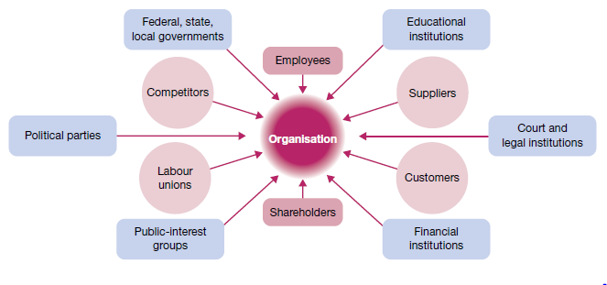  
Fig 1.6.2 Multiple stakeholders in the environment of organizations**

Sometimes called the *task environment*, the specific environment and the stakeholders are distinct for each organisation. They can also change over time according to the company’s unique customer base, operating needs and circumstances. Important stakeholders common to the specific environment of most organisations include:

* *customers* — specific consumer or client groups, individuals and organisations that purchase the organisation’s goods and/or use its services
* *suppliers* — specific providers of the human, information and financial resources and raw materials needed by the organisation to operate
* *competitors* — specific organisations that offer the same or similar goods and services to the same consumer or client groups
* *regulators* — specific government agencies and representatives, at the local, state and national levels, that enforce laws and regulations affecting the organisation’s operations.

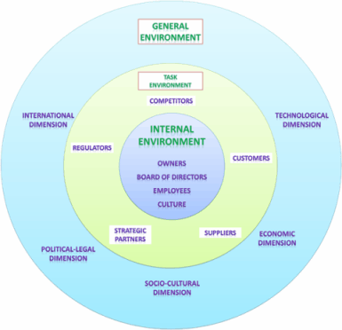

**Fig 1.6.3 Multiple stakeholders in the environment of organizations - 2**

**Environmental uncertainty**

The fact is that many organisations today face great uncertainty in their external environments. In this sense, **environmental uncertainty** means that there is a lack of complete information regarding what developments will occur in the external environment. This makes it difficult to predict future states of affairs and to understand their potential implications for the organisation. Figure below describes environmental uncertainty along two dimensions — complexity, or the number of different factors in the environment, and the rate of change in these factors.

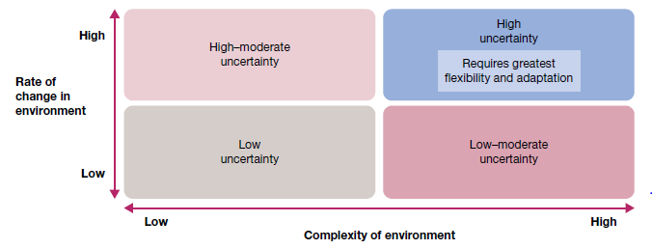

**Fig 1.6.3 Dimensions of uncertainty in organisational environments**

# UNIT II

## 2.1 Information technology and the new workplace

Progressive organisations are doing all they can to design work settings for high performance in an environment where ‘speed to market’, ‘quick response’, ‘fast cycle time’ and ‘time-based competition’ are top priorities.

People work at ‘smart’ stations supported by computers that allow sophisticated voice, image, text and other data-handling operations. Many of these stations are temporary spaces that telecommuters ‘visit’ during those times when they are in the main office; otherwise they work from virtual offices — on the road, anywhere. Voice messaging uses the voice recognition capabilities of computers to take dictation, answer the telephone and relay messages. Databases are easily accessed and shared to solve problems, and to prepare and analyse reports.

Documents drafted via word processing are stored for later retrieval and/or sent via electronic mail or facsimile transmission to other people. Filing cabinets are few, and little paper is found. Meeting notes are written on electronic pads or jotted in palm-held electronic diaries

. All are easily uploaded into computer files. Mail arrives and is routed to its destination via computer, where it is electronically prioritized according to its importance and linked to relevant databases to speed problem-solving. Computer conferencing and videoconferencing are commonplace. E-meetings allow people separated by great distances — distributed even around the world — to work together on projects every day without meeting personally face to face.

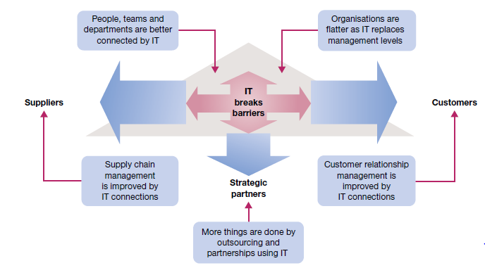

**Fig 2.1.1 Information systems and the nature of managerial work**

**Information technology and the changing business**

One of the most significant business developments of all time is **electronic commerce**, or ‘e-commerce’

The stages of development in e‐commerce are as follows.

1. *Secure an online identity*. Organisations at this stage have a web address and most likely a posted home page.

2. *Establish a web presence*. Organisations at this stage use their home page for advertising or promotional purposes; it offers company and/or product information, but does not allow visitors online queries or ordering.

3. *Enable e‐commerce*. Organisations at this stage are viable e‐commerce businesses whose websites allow visitors to order products online.

4. *Provide e‐commerce and customer relationship management*. Organisations at this stage use their websites to develop and maintain relationships with customers by serving key processes, such as checking status of orders or inventory levels online.

5. *Use a service application model*. Organisations at this stage use advanced website capabilities to fully serve business functions and processes such as financial management and human resources.

**2.1.1 Information and Information systems**

**Information systems** use the latest in information technology to collect, organise and distribute data in such a way that they become meaningful as information. The integration of information systems is an essential element of high productivity.

The five essential characteristics of useful information are as follows.

i. *Timeliness*. The information is available when needed; it meets deadlines for decision-making and action.

ii. *Quality*. The information is accurate and reliable; it can be used with confidence.

iii. *Completeness*. The information is complete and sufficient for the task at hand; it is as current and as up to date as possible.

iv. *Relevance*. The information is appropriate for the task at hand; it is free from extraneous or irrelevant material.

v. *Understandability*. The information is presented in proper form, easily understood by the user; it is free from unnecessary detail; and the scope of the collected information is neither too narrow nor too broad.

**Types of managerial decisions**

**Programmed decisions** — that is, solutions already available from past experience to solve problems that are familiar, straightforward and clear with respect to information needs. These decisions apply best to problems that are matters of routine; although perhaps not predictable, they can at least be anticipated. This means that decisions can be planned or programmed in advance, to be implemented as needed.

Unstructured problems require **non-programmed decisions** that craft novel solutions to meet the demands of the unique situation at hand. Most problems faced by higher level managers are of this type, with the problems often involving choice of strategies and objectives in situations of some uncertainty.

## 2 Decision Making Process

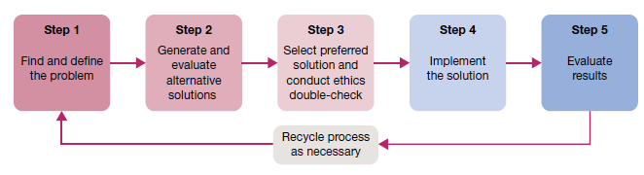

Fig 2.2.1 Steps in decision making and problem solving

***Decision making step 1: Identify and define the problem***

The first step in decision making is to find and define the problem. This is a stage of information gathering, information processing and deliberation. The way a problem is originally defined can have a major impact on how it is eventually resolved. Three common mistakes may occur at this vital first step in decision-making. *Mistake number 1* is defining the problem too broadly or too narrowly. To take a classic example, the problem stated as ‘build a better mousetrap’ might be better defined as ‘get rid of the mice’. That is, managers should define problems so as to give themselves the best possible range of problem-solving options. *Mistake number 2* is focusing on symptoms instead of causes. Symptoms are indicators that problems may exist, but they shouldn’t be mistaken for the problems themselves. Managers should be able to spot problem symptoms (e.g. a drop in performance). But instead of treating the symptoms (such as simply encouraging higher performance), managers should deal with their root causes (such as discovering the workers’ need for training in the use of a complex new computer system). *Mistake number 3* is choosing the wrong problem to deal with. Managers should set priorities and deal with the most important problems first. They should also give priority to problems that are truly solvable.

***Decision making step 2: Generate and evaluate possible solutions***

Once the problem is defined, it is possible to formulate one or several potential solutions. At this stage, more information is gathered, data are analysed, and the pros and cons of possible alternative courses of action are identified. This effort to locate, clarify and evaluate alternative solutions is important to successful problem-solving. The involvement of other people is vital here in order to maximise information and build commitment. The end result can only be as good as the quality of the alternative solutions generated in this step. The better the pool of alternatives, the more likely a good solution will be achieved. Common errors in this stage include selecting a particular solution too quickly and choosing an alternative that, although convenient, has damaging side effects or is not as good as others that might be discovered with extra effort. The analysis of alternatives should determine how well each possible course of action deals with the problem while taking into account the environment within which the problem exists. A very basic evaluation involves **cost–benefit analysis**, the comparison of the cost of an alternative and the expected benefits. At a minimum, the benefits of a chosen alternative should be greater than its costs. Typical criteria for evaluating alternatives include the following.

* *Benefits*. What are the ‘benefits’ of using the alternative to solve a performance deficiency or take advantage of an opportunity?
* *Costs*. What are the ‘costs’ of implementing the alternative, including resource investments as well as potential negative side effects?
* *Timeliness*. How fast will the benefits occur and a positive impact be achieved?
* *Acceptability*. To what extent will the alternative be accepted and supported by those who must work with it?
* *Ethical soundness*. How well does the alternative meet acceptable ethical criteria in the eyes of the various stakeholders?

***Decision making step 3: Choose a solution***

At this point in the decision-making process an actual decision is made to select a particular course of action. Just how this is done and by whom must be successfully resolved in each problem situation. Management theory recognises differences between the classical model and the behavioural model of decision-making, as shown in figure. The **classical decision model** views the manager as acting in a certain world. Here, the manager faces a clearly defined problem and knows all possible action alternatives as well as their consequences. As a result, he or she makes an **optimising decision** that gives the absolute best solution to the problem. The classical approach is a very rational model that assumes perfect information is available for decision-making.

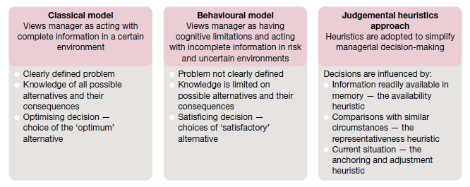

**Fig 2.2.2 Classical, behavioural and judgemental heuristics approaches in decision‐making**

***Decision making step 4: Implement the solution***

Given the choice of preferred solution, appropriate actions must be taken to fully implement it. This is the stage at which directions are finally set and problem‐solving actions are initiated. Nothing new can or will happen according to plan unless action is taken. Managers not only need the determination and creativity to arrive at a decision, they also need the ability and willingness to implement it.

The ‘ways’ in which previous steps have been accomplished can have an additional and powerful impact at this stage of implementation. Difficulties at this stage often trace to the lack‐of‐participation error, or the failure to adequately involve those people whose support is necessary to ensure a decision’s complete implementation. Managers who use participation wisely get the right people involved in decisions and problem‐solving from the beginning. When they do, implementation typically follows quickly, smoothly and to everyone’s satisfaction. Involvement not only makes everyone better informed, it also builds the commitments needed for implementation.

***Decision making step 5: Evaluate results***

The decision‐making process is not complete until results are evaluated. If the desired results are not achieved, the process must be renewed to allow for corrective actions. In this sense, evaluation is a form of managerial control. It involves a continuing commitment to gather information on performance results. Both the positive and negative consequences of the chosen course of action should be examined.

If the original solution appears inadequate, a return to earlier steps in problem‐solving may be required to generate a modified or new solution. In this way, problem‐solving becomes a dynamic and ongoing activity within the management process. Evaluation is also made easier if the solution involves clear objectives that include measurable targets and timetables.

## 2.3 Planning

Planning involves selecting missions and objectives and the actions to achieve them, it requires decision-making that is choosing future courses of action from among alternatives. Plans thus provide a rational approach to achieving pre-selected objectives.

The role of the planning function in the management process

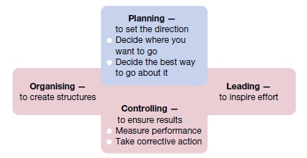

**2.3.1 The role of the planning function in the management process**

**Types of Plans**

***mission or purpose***

the mission or purpose identifies the basic function or the task of an enterprise or an agency or any part of it.

***Objectives***

This is the first step in planning the action plan of the organization. Objectives are the basics of every company and the desired objective/result that the company plans on achieving, so they are the endpoint of every planning activity.

For example one of the objectives of an organization could be to increase sales by 20%. So the manager will plan all activities of the organization with this end objective in mind. While framing the objectives of the organization some points should be kept in mind.

* Objectives should be framed for a single activity in mind.
* They should be result oriented. The objective must not frame any actions
* Objectives should not be vague, they should be quantitative and measurable.
* They should not be unrealistic. Objectives must be achievable.

***Strategy***

This obviously is the next type of plan, the next step that follows objectives. A strategy is a complete and all-inclusive plan for achieving said objectives. A strategy is a plan that has three specific dimensions

1. Establishing long-term objectives
2. Selecting a specific course of action
3. allocating the necessary resources needed for the plan

Forming strategy is generally reserved for the top level of management. It actually defines all future decisions and the company’s long-term scope and general direction.

***Policy***

Policies are generic statements, which are basically a guide to channelize energies towards a particular strategy. It is an organization’s general way of understanding, interpreting and implementing strategies. Like for example, most companies have a return policy or recruitment policy or pricing policy etc.

Policies are made across all levels of management, from major policies at the top-most level to minor policies. The managers need to form policies to help the employees navigate a situation with predetermined decisions. They also help employees to make decisions in unexpected situations.

***Procedure***

Procedures are the next types of plan. They are a stepwise guide for the routine to carry out the activities. These stepwise sequences are to be followed by all the employees so the activities can be fulfilled in an organized manner.

The procedures are described in a chronological order. So when the employees follow the instructions in the order and completely, the success of the activity is pretty much guaranteed.

Take for example the procedure of admission of a student in a college. The procedure starts with filling out an application form. It will be followed by a collection of documents and sorting the applications accordingly.

***Rules***

Rules are very specific statements that define an action or non-action. Also, rules allow for no flexibility at all, they are final. All employees of the organization must compulsorily follow and implement the rules. Not following rules can have severe consequences.

Rules create an environment of discipline in the organization. They guide the actions and the behaviour of all the employees of the organization. The rule of “no smoking” is one such example.

***Program***

Programmes are an in-depth statement that outlines a company’s policies, rules, objectives, procedures etc. These programmes are important in the implementation of all types of plan. They create a link between the company’s objectives, procedures and rules.

Primary programmes are made at the top level of management. To support the primary program all managers will make other programs at the middle and lower levels of management.

***Methods***

Methods prescribe the ways in which in which specific tasks of a procedure must be performed. Also, methods are very specific and detailed instructions on how the employees must perform every task of the planned procedure. So managers form methods to formalize routine jobs.

Methods are very important types of plan for an organization. They help in the following ways

* give clear instructions to the employees, removes any confusion
* Ensures uniformity in the actions of the employees
* Standardizes the routine jobs
* Acts as an overall guide for the employees and the managers

***Budget***

A budget is a statement of expected results the managers expect from the company. Budgets are also a quantitative statement, so they are expressed in numerical terms. A budget quantifies the forecast or future of the organization.

There are many types of budgets that managers make. There is the obvious financial budget, that forecasts the profit of the company. Then there are operational budgets generally prepared by lower-level managers. Cash budgets monitor the cash inflows and outflows of the company.

## 2.4 The planning process

The planning process begins with an organisation identifying specific outcomes that it wishes to achieve. It may set different targets depending on the environment it encounters, especially where the environment is uncertain or changing rapidly. This ‘what-if’ or scenario planning is practised by an increasing number of organisations. Organisations may also include in their plans action to help shape or stabilize the environment. Such action could include lobbying governments locally and overseas, creating industry networks, or philanthropy. The organisation’s **plan** is a statement of the actual steps required to achieve its objectives. There are five sequential action steps in the systematic planning process.

**1. *Define your objectives*.** Identify desired outcomes or results in very specific ways. Know where you want to go; be specific enough that you will know you have arrived when you get there or know how far off the mark you are at various points along the way.

**2. *Determine where you currently stand in relation to objectives*.** Evaluate current accomplishments relative to the desired results. Know where you stand in reaching the objectives; know what strengths work in your favour and what weaknesses may hold you back.

**3. *Develop perspectives regarding future conditions*.** Try to forecast potential future events. Generate alternative ‘scenarios’ for what may happen; identify for each scenario things that may help or hinder progress towards your objectives. Systematically vary the drivers for each scenario to determine possible outcomes.

**4. *Analyse and choose among action alternatives*.** List and carefully evaluate the possible actions that may be taken. Choose the alternative(s) most likely to accomplish your objectives; describe step by step what must be done to follow the chosen course of action.

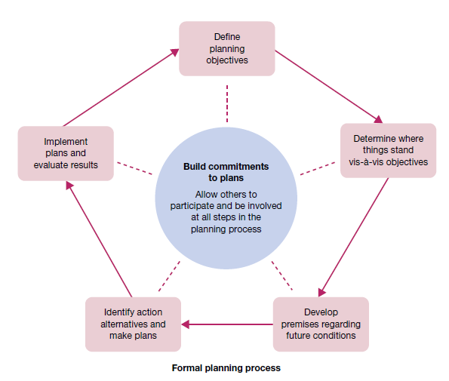

**Fig 2.4.1 How participation and involvement help build commitments to plans**

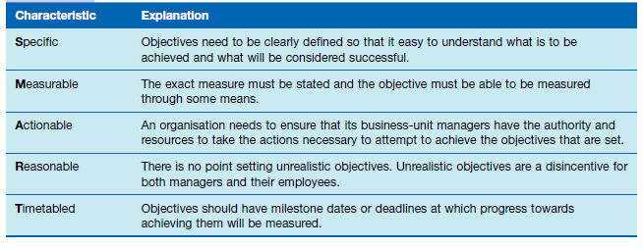

**Fig 2.4.2 The SMART model of establishing effective organisational objectives**

**5. *Implement the plan and evaluate results***. Take action and carefully measure your progress towards objectives.

Do what the plan requires; evaluate results; take corrective action, and revise plans as needed. The planning process described is an application of the decision-making process introduced in the chapter on information and decision-making. It is a systematic way to approach two important tasks: setting performance objectives, and deciding how to best achieve them. Importantly, in the complex setting of the modern workplace this is not a process that managers do while working alone in quiet rooms, free from distractions, and at scheduled times. Rather, planning should be part of a manager’s everyday work routine. It should be an ongoing activity that is done continuously even while dealing with an otherwise hectic and demanding work setting.6 Importantly, the best planning in management always involves those people whose work efforts will eventually determine whether the objectives are accomplished.

* + 1. **Features Of Planning**

**Planning is Goal Oriented:**

All plans arise from objectives. Objectives provide the basic guidelines for planning activities. Planning has no meaning unless it contributes in some positive manner to the achieve­ment of predetermined goals.

**Planning is a Primary Function:**

Planning is the foundation of manage­ment. It is a parent exercise in management process. It is a preface to business activities. According to Koontz, “Planning provides the basic foundation from which all future management functions arise”.

**Planning is All Pervasive:**

Planning is a function of all managers. It is needed and practiced at all managerial levels. Planning is inherent in everything a manager does.

**Planning is a Mental Exercise:**

Planning is a mental process involving imagination, foresight and sound judgment. Planning compels managers to abandon guesswork and wishful thinking. It makes them think in a logical and systematic manner.

**Planning is a Continuous Process:**

Planning is continuous. It is a never-end­ing activity. It is an ongoing process of adjustment to change. There is always need for a new plan to be drawn on the basis of new demands and changes in the circumstances.

**Planning Involves Choice:**

Planning essentially involves choice among various alternative courses of action. If there is one way of doing some­thing, there is no need for planning. The need for planning arises only when alternatives are available.

**Planning is Forward Looking:**

Planning means looking ahead and pre­paring for the future. It means peeping into the future, analyzing it and preparing for it. Managers plan today with a view to flourish tomorrow. Without planning, business becomes random in nature and decisions would become meaningless, adhoc choices.

**Planning is Flexible:**

Planning is based on a forecast of future events. Since future is uncertain, plans should be reasonably flexible. When market conditions change, planners have to make necessary changes in the existing plans.

**Planning is an Integrated Process:**

Plans are structured in a logical way wherein every lower-level plan serves as a means to accomplish higher level plans. They are highly interdependent and mutually supportive.

**Planning Includes Efficiency and Effectiveness Dimensions:**

Plans aim at deploying resources economically and efficiently. They also try to ac­complish what has been actually targeted. The effectiveness of plans is usually dependent on how much it can contribute to the predetermined objectives.

**2.4.2 Importance Of Planning**

***Increases efficiency:*** Planning makes optimum utilization of all available resources. It helps to reduce the wastage of valuable resources and avoids their duplication. It aims to give the highest returns at the lowest possible cost. It thus increases the overall efficiency.

***Reduces business-related risks:*** There are many risks involved in any modern business. Planning helps to forecast these business-related risks. It also helps to take the necessary precautions to avoid these risks and prepare for future uncertainties in advance. Thus, it reduces business risks.

***Facilitates proper coordination:*** Often, the plans of all departments of an organization are well coordinated with each other. Similarly, the short-term, medium-term and long-term plans of an organization are also coordinated with each other. Such proper coordination is possible only because of efficient planning.

***Aids in Organizing:*** Organizing means to bring together all available resources, i.e. 6 Ms. Organizing is not possible without planning. It is so, since, planning tells us the number of resources required and when are they needed. It means that planning aids in organizing in an efficient way.

***Gives right direction:*** Direction means to give proper information, accurate instructions and useful guidance to the subordinates. It is impossible without planning. It is because planning tells us what to do, how to do it and when to do it. Therefore, planning helps to give the right direction.

***Keeps good control:*** With control, the actual performance of an employee is compared with the plans, and deviations (if any) are found out and corrected. It is impossible to achieve such control without the right planning. Therefore, planning becomes necessary to keep good control.

***Helps to achieve objectives:*** Every organization has certain objectives or targets. It keeps working hard to fulfill these goals. Planning helps an organization to achieve these aims, but with some ease and promptness. Planning also helps an organization to avoid doing some random ( done by chance) activities.

***Motivates personnel:*** A good plan provides various financial and non-financial incentives to both managers and employees. These incentives motivate them to work hard and achieve the objectives of the organization. Thus, planning through various incentives helps to motivate the personnel of an organization.

***Encourages creativity and innovation:*** Planning helps managers to express their creativity and innovation. It brings satisfaction to the managers and eventually a success to the organization.

***Helps in decision-making:*** A manager makes many different plans. Then the manager selects or chooses the best of all available strategies. Making a selection or choosing something means to take a decision. So, decision-making is facilitated by planning.

## 2.5 Tools, techniques and processes

Today’s planners use a broad array of planning tools, techniques and processes. These include forecasting, specific contingency planning, benchmarking, participatory or team-based planning, and staff planners.

**Forecasting**

A forecast is a vision of the future. Forecasting is the process of making assumptions about what will happen in the future.15 All good plans involve forecasts, either implicit or explicit. Some forecasts are based on *qualitative forecasting*, which uses expert opinions to predict the future. In this case, a single person of special expertise or reputation or a panel of experts may be consulted. Others involve *quantitative forecasting* that uses mathematical and statistical analysis of data banks to predict future events. Time-series analysis makes predictions by using statistical routines such as regression analysis to project past trends into the future. General economic trends are often forecast by econometric models that simulate events and make predictions based on relationships discovered among variables in the models. Statistical analysis of opinion polls and attitude surveys, such as those reported in newspapers and on television, is typically used to predict future consumer tastes, employee preferences and political choices, among other issues. In the final analysis, forecasting always relies on human judgement.

**Contingency planning**

Activity undertaken to ensure that proper and immediate follow-up steps will be taken by a management and employees in an emergency. Its major objectives are to ensure (1) containment of damage or injury to, or loss of, personnel and property, and (2) continuity of the key operations of the organization. Contingency planning identifies alternative courses of action that can be implemented if and when an original plan proves inadequate because of changing circumstances.

**Scenario planning and contingency planning**

Scenario planning is the long-term version of contingency planning. Identifying a range of different possible future scenarios helps organisations operate more flexibly and respond more rapidly in uncertain and changing environments.

**Benefits of scenario planning**

Scenario planning is not forecasting what planners think will happen. Rather, it consists of developing possible plausible scenarios of the future, with reference to a particular firm, that make different assumptions about forces driving the market and including different uncertainties.16 This allows the manager or planner to consider how these environmental uncertainties might affect the firm’s strategy, and thus to plan for such eventualities should they occur.

Scenario planning improves focus and flexibility

Scenario planning improves action orientation

Scenario planning improves coordination

Scenario planning improves time management

Scenario planning improves control

**Benchmarking**

Another important influence on the success or failure of planning involves the frame of reference used as a starting point. All too often planners have only a limited awareness of what is happening outside the immediate work setting. Successful planning must challenge the status quo; it cannot simply accept things the way they are. One way to do this is through benchmarking, a technique that makes use of external comparisons to better evaluate an organisation’s current performance and identify possible actions for the future. The purpose of benchmarking is to find out what other people and organizations are doing very well and then to plan how to incorporate these ideas into your organisation’s operations

This powerful planning technique is increasingly popular in today’s competitive business world. It is a way for progressive companies to learn from other ‘excellent’ companies, not just competitors. It allows them to analyse and thoroughly compare all systems and processes for efficiencies and opportunities for innovation.

**Staff planners**

As the planning needs of organisations grow, there is a corresponding need to increase the sophistication of the overall planning system itself. In some cases, staff planners are employed to help coordinate planning for the organisation as a whole or for one of its major components. These planners should be skilled in all steps of the formal planning process, including the benchmarking and scenario-planning approaches just discussed. They should also understand the advisory nature of their roles. Given clear responsibilities and their special planning expertise, staff planners can bring focus to efforts to accomplish important planning tasks. But one risk is a tendency for a communication ‘gap’ to develop between staff planners and line managers. This can cause a great deal of difficulty. Resulting plans may lack relevance, and line personnel may lack commitment to implement them even if they are relevant. One trend in organisations today is to de-emphasise the role of large staff planning groups and to place much greater emphasis on the participation and involvement of line managers in the planning process.

**Management by objectives**

A useful planning technique that helps integrate planning and controlling is management by objectives, or just MBO. This is a structured process of regular communication in which a manager or team leader works with staff or team members to jointly set performance objectives and review results accomplished. MBO creates an agreement between the two parties regarding:

1. Performance objectives for a given time period

2. Plans through which they will be accomplished

3. Standards for measuring whether they have been accomplished

4. Procedures for reviewing performance results.

Of course, both parties in any MBO agreement are supposed to work closely together to fulfil the terms of the agreement.

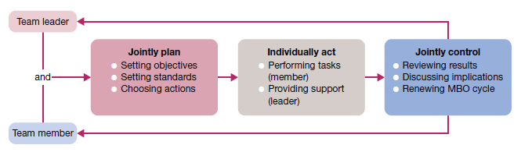

**Fig 2.5.1 Performance objectives in MBO**

**Participation and involvement**

Planning is a process, not an event, and ‘participation’ is a key component of the planning process. Participatory planning means that the process includes people who will be affected by the resulting plans and/or who will be asked to help implement them. This brings to the organisation many benefits. Participation can increase the creativity and information available for planning. It can also increase the understanding, acceptance and commitment of people to final plans. Indeed, planning should be organized and accomplished in a participatory manner that includes the contributions of many people representing diverse responsibilities and vantage points. This includes the level of strategic planning, once considered only the province of top management. The more aware all levels are of strategic plans and the more they are involved in helping to establish them, the greater the commitment throughout the organisation to their accomplishment.

**Planning Process :**

1] Recognizing Need for Action

An important part of the planning process is to be aware of the business opportunities in the firm’s external environment as well as within the firm. Once such opportunities get recognized the managers can recognize the actions that need to be taken to realize them. A realistic look must be taken at the prospect of these new opportunities and SWOT analysis should be done.

Say for example the government plans on promoting cottage industries in semi-urban areas. A firm can look to explore this opportunity.

2] Setting Objectives

This is the second and perhaps the most important step of the planning process. Here we establish the objectives for the whole organization and also individual departments. Organizational objectives provide a general direction, objectives of departments will be more planned and detailed.

Objectives can be long term and short term as well. They indicate the end result the company wishes to achieve. So objectives will percolate down from the managers and will also guide and push the employees in the correct direction.

3] Developing Premises

Planning is always done keeping the future in mind, however, the future is always uncertain. So in the function of management certain assumptions will have to be made. These assumptions are the premises. Such assumptions are made in the form of forecasts, existing plans, past policies, etc.

These planning premises are also of two types – internal and external. External assumptions deal with factors such as political environment, social environment, the advancement of technology, competition, government policies, etc. Internal assumptions deal with policies, availability of resources, quality of management, etc.

These assumptions being made should be uniform across the organization. All managers should be aware of these premises and should agree with them.

4] Identifying Alternatives

The fourth step of the planning process is to identify the alternatives available to the managers. There is no one way to achieve the objectives of the firm, there is a multitude of choices. All of these alternative courses should be identified. There must be options available to the manager.

Maybe he chooses an innovative alternative hoping for more efficient results. If he does not want to experiment he will stick to the more routine course of action. The problem with this step is not finding the alternatives but narrowing them down to a reasonable amount of choices so all of them can be thoroughly evaluated.

5] Examining Alternate Course of Action

The next step of the planning process is to evaluate and closely examine each of the alternative plans. Every option will go through an examination where all there pros and cons will be weighed. The alternative plans need to be evaluated in light of the organizational objectives.

For example, if it is a financial plan. Then it that case its risk-return evaluation will be done. Detailed calculation and analysis are done to ensure that the plan is capable of achieving the objectives in the best and most efficient manner possible.

6] Selecting the Alternative

Finally, we reach the decision making stage of the planning process. Now the best and most feasible plan will be chosen to be implemented. The ideal plan is the most profitable one with the least amount of negative consequences and is also adaptable to dynamic situations.

The choice is obviously based on scientific analysis and mathematical equations. But a managers intuition and experience should also play a big part in this decision. Sometimes a few different aspects of different plans are combined to come up with the one ideal plan.

7] Formulating Supporting Plan

Once you have chosen the plan to be implemented, managers will have to come up with one or more supporting plans. These secondary plans help with the implementation of the main plan. For example plans to hire more people, train personnel, expand the office etc are supporting plans for the main plan of launching a new product. So all these secondary plans are in fact part of the main plan.

8] Implementation of the Plan

And finally, we come to the last step of the planning process, implementation of the plan. This is when all the other functions of management come into play and the plan is put into action to achieve the objectives of the organization. The tools required for such implementation involve the types of plans- procedures, policies, budgets, rules, standards etc.

# UNIT 3

## 3.1 Organisational control

Controlling is the process of measuring performance and taking action to ensure the planned outcomes are achieved. Control is aimed at ensuring that plans are fulfilled and that performance targets are met. Control can be important not only for guaranteeing that the performance level is met but also for ensuring that performance is consistent. Carefully controlling the performance levels of an organisation requires accurate and timely flows of information on the key operational variables and outcomes. There is a need for control mechanisms that can quickly detect and correct unlawful and corrupt behaviour at all levels within an organisation.

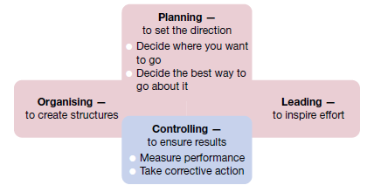

**Fig 3.1: The role of the controlling function in the management process**

**3.1.1 Steps in the control process**

The management control process involves four steps.

1. Establish objectives and standards.

2. Measure actual performance.

3. Compare results with objectives and standards.

4. Take corrective action as needed.

**Step 1: Establish objectives and standards**

The control process starts with planning, when performance objectives and standards for measuring them are set. Performance objectives, furthermore, should represent key results to be achieved. The focus in planning should be on describing ‘critical’ or ‘essential’ results that will make a substantial difference in the success of the organisation. The standards are important, too, and they must also be considered right from the beginning. As key results are identified, the standards or specific measures that will be taken to indicate success or failure in their accomplishment must also be specified.

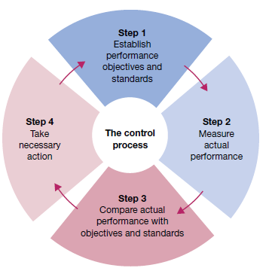

**Fig 3.1.2 Four steps in management control**

Two types of standards are common to the organisational control process. Output standards measure performance results in terms of outcomes like quantity, quality, cost or time taken to accomplish work. Examples of output standards include percentage error rate, dollar deviation from budgeted expenditures, and the number of units produced or customers served in a time period. Input standards, on the other hand, measure effort in terms of the amount of work expended in task performance. They are used in situations where outputs are difficult or expensive to measure. Examples of input standards include conformance to rules and procedures, efficiency in the use of resources, and work attendance or punctuality.

**Step 2: Measure actual performance**

The goal is to accurately measure the performance results (output standards) and/or the performance efforts (input standards). In both cases, the measurement must be accurate enough to spot significant differences between what is really taking place and what was originally planned. A common management failure in this regard is an unwillingness or inability to measure the performance of people at work. Yet without measurement, effective control is not possible. Increasingly, managers are required to assess organisational performance. It can be achieved through analysing statistical/quantitative data collected by employees, supervisors or managers, or by an external organisation, and typically presented in the form of spreadsheets. Alternatively, managers can use qualitative techniques such as observing employees at work. This is often referred to as ‘management by wandering around’ (MBWA).

There are many activities for which it is difficult to develop accurate standards, and there are many activities that are hard to measure. It may be quite simple, for example, to establish labor-hour standards for the production of a mass-produced item and it may be equally simple to measure performance against these standards, but in the less technical kinds of work. For example, controlling the work of the industrial relations manager is not easy because definite standards cannot be easily developed. The superior of this type of managers often rely on vague standards, such as the attitude of labor unions, the enthusiasm, and loyalty of subordinates, the index of labor turnover and/or industrial disputes etc. In such cases, the superior’s measurements are often equally vague.

**Step 3: Compare results with objectives and standards**

The third step in the control process is to compare measured performance with objectives and standards to establish the need for action. This step can be expressed as the following control equation:

Need for action = Desired performance − Actual performance

There are different ways of comparing desired and actual performance. A historical comparison uses past performance as a benchmark for evaluating current performance. A relative comparison uses the performance achievements of other people, work units or organisations as the evaluation standard. An engineering comparison uses engineered standards that are set scientifically through such methods as time and motion studies. For instance, the delivery routines of drivers for a courier company are carefully measured in terms of the expected time taken to make a delivery on various routes.

**Step 4: Take corrective action**

The control equation indicates that the greater the measured difference between desired and actual performance, the greater the need for action. The final step in the control process, accordingly, is taking any action necessary to correct or improve things. This allows for a judicious use of management by exception — the practice of giving priority attention to situations that show the greatest need for action. This approach can save valuable time, energy and other resources, while allowing all efforts to be concentrated on the areas of greatest need.

Two types of exceptions may be encountered. The first is a problem situation in which actual performance is below the standard. The reasons for this performance deficiency must be understood. Corrective action is required to restore performance to the desired level. The second exception is an opportunity situation in which actual performance is above the standard. The reasons for this extraordinary performance must also be understood. Action should then be taken to continue this higher level of accomplishment in the future. The original plan, objectives and standards can also be reviewed to determine whether they should be updated.

For example, the branch manager of a bank might discover that more counter clerks are needed to meet the five-minute customer-waiting standard set earlier. Control can also reveal inappropriate standards and in that case, the corrective action could involve a change in the original standards rather than a change in performance.

**3.1.2 Types of controls**

**3.1.2.1 Process Control**

There are three major types of managerial controls — *feedforward, concurrent and feedback controls*. Each is relevant to a different phase of the organisation’s input–throughput– output cycle of activities. Each offers significant opportunities for actions to be taken that advance organisational productivity and high performance, each offers the opportunity for performance oriented organisational and personal learning through systematic assessment of actions and results.

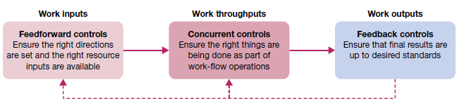

**Fig 3.1.3 Feedforward, concurrent and feedback controls in the management process**

**Feedforward controls**

Feedforward controls, also called preliminary controls, are accomplished before a work activity begins. They ensure that objectives are clear, that proper directions are established, and that the right resources are available to accomplish them, feedforward controls are preventive in nature. They are designed to eliminate the potential for problems later on in the process by asking an important but often neglected question: what needs to be done before we begin? This is a forward thinking and active approach to control rather than a reactive and defensive one. The quality of resources is a key concern of feedforward controls.

**Concurrent controls**

Concurrent controls focus on what happens during the work process. Sometimes called steering controls, they monitor ongoing operations and activities to make sure things are being done according to plan. Ideally, concurrent controls allow corrective actions to be taken before a task is completed. The key question is: What can we do to improve things before we finish? Here, the focus is on quality of activities during the work process. This approach to control can reduce waste in the form of unacceptable finished products or services.

**Feedback controls** Feedback controls, also called post action controls, take place after work is completed. They focus on the quality of end results rather than on inputs and activities. They ask the question: Now that we are finished, how well did we do?

## 3.2 Motivation

Motivation is the act of stimulating someone or oneself to get a desired course of action. Motivation is forces within the individual that account for the level, direction and persistence of effort expended at work.

**3.2.1 Motivation and rewards**

A reward is a work outcome of positive value to the individual. A motivational work setting is rich in rewards for people whose performance accomplishments help meet organisational objectives. In management, it is useful to distinguish between two types of rewards, extrinsic and intrinsic.

**Extrinsic rewards** are externally administered. They are valued outcomes given to someone by another person, typically a supervisor or higher level manager. Common workplace examples are pay bonuses, promotions, time off, special assignments, office fixtures, awards and verbal praise. In all cases, the motivational stimulus of extrinsic rewards originates outside of the individual. Intrinsic rewards, on the other hand, are self-administered. They occur ‘naturally’ as a person performs a task and are, in this sense, built directly into the job itself. The major sources of intrinsic rewards are the feelings of competency, personal development and self-control people experience in their work. In contrast to extrinsic rewards, the motivational stimulus of intrinsic rewards is internal and does not depend on the actions of some other person.

**3.2.2 Importance of Employee Motivation**

*Organization Goal Achievement*

*Enduring Relationship*

*Workforce Stability*

*Role of Human Resource*

*Reduction in Employees’ Turnover*

**3.2.3 Theories of Motivation**

*Content theories of motivation* help us to understand human needs and how people with different needs may respond to different work situations. The *process theories of motivation* offer additional insights into how people give meaning to rewards and then respond with various work-related behaviours. The *reinforcement theory of motivation* focuses attention on the environment as a major source of rewards and influence on human behavior

***a. Hierarchy of needs theory***

Maslow offers two principles to describe how these needs affect human behaviour. The deficit principle states that a satisfied need is not a motivator of behaviour. People are expected to act in ways that satisfy deprived needs; that is, needs for which a ‘deficit’ exists. The progression principle states that a need at one level does not become activated until the next lower level need is already satisfied. People are expected to advance step-by-step up the hierarchy in their search for need satisfactions. At the level of self-actualisation, the more these needs are satisfied, the stronger they are supposed to grow. According to Maslow, a person should continue to be motivated by opportunities for self-fulfilment as long as the other needs remain satisfied

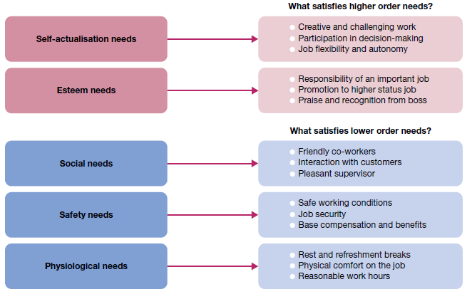

**Fig 3.2.1 Opportunities for satisfaction in Maslow’s hierarchy of human needs**

***ERG theory***

The existence, relatedness and growth (ERG) theory proposed by Clayton Alderfer, collapses Maslow’s five needs categories into three. *Existence needs* are desires for physiological and material wellbeing. *Relatedness needs* are desires for satisfying interpersonal relationships. *Growth needs* are desires for continued psychological growth and development. Alderfer’s ERG theory also differs from Maslow’s theory in other respects. This theory does not assume that lower level needs must be satisfied before higher level needs become activated. According to ERG theory, any or all of these three types of needs can influence individual behaviour at a given time. Alderfer also does not assume that satisfied needs lose their motivational impact. ERG theory thus contains a unique *frustration*–*regression principle*, according to which an already satisfied lower level need can become reactivated and influence behaviour when a higher level need cannot be satisfied. Alderfer’s approach offers an additional means for understanding human needs and their influence on people at work.

## Leadership

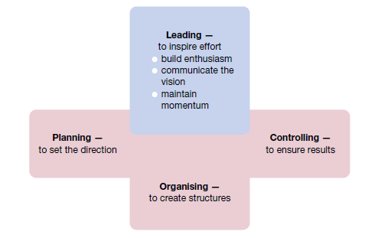

**Fig 3.3.1 Leading viewed in relationship to the other management functions**

**3.3.1 Traits of an ethical leader**

***The personality to defy groupthink***

Good leaders display intelligence and imagination to create a compelling vision of the future, and bring those who can deliver it with them. A good leader must be trustworthy and display unshakeable integrity, be action-oriented, resilient in the face of setbacks while treating people with respect, not as mere units of production. They have rid themselves of delusion and are brutally honest with themselves, know when to take risks and when to play it safe. Leaders are courageous, defy groupthink and accept the backlash against their unorthodox practices.

***The ability to set a good example***

A defining feature of the ethical leader is that in addition to the foundational qualities mentioned above, setting a consistently good example for others to follow. They have created a moral matrix that people internalise and operate from day to day.

***Selflessness***

Ethical leaders are strong when it comes to selfless service in the interests of the greater good.

***They’re not afraid to be challenged***

Having one’s subordinates call you out, disagree with you, challenge your judgement; all of this calls for great understanding and tolerance. Ethical leaders understand that it’s part of a culture of continuous improvement.

***They take responsibility for everything***

The ethical leader accepts that they are either directly or indirectly responsible for everything that happens in the organisation. They understand that blame shifting and finger pointing is a failure of leadership. The ethical leader does not resort to the ‘plausible deniability’ defence. Ultimately, good ethics is good business.

**3.3.2 The nature of leadership**

***Leadership and vision***

Today, leadership is often associated with **vision** — a future that you hope to create or achieve in order to improve on the present state of affairs. Truly great leaders are extraordinarily good at turning their visions into concrete results. Importantly, this involves the essential ability to communicate your vision in such a way that others commit their hard work to its fulfillment. .

***Power and influence***

The foundations of effective leadership lie in the way a manager uses power to influence the behavior of other people. Power is the ability to get someone else to do something you want done. It is the ability to make things happen the way you want them to. Need for power should not be a desire to control for the sake of personal satisfaction; it is a desire to influence and control others for the good of the group or organisation as a whole.

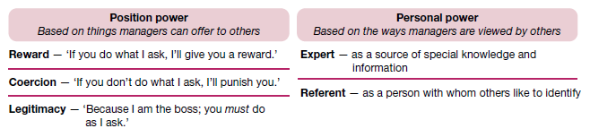

**Fig 3.3.2 Sources of position power and personal power used by managers**

***Sources of position power***

One important source of power is a manager’s official status, or position, in the organisation’s hierarchy of authority. Whereas anyone holding a managerial position theoretically has this power, how well it is used will vary from one person to the next. Consequently, leadership success will vary as well. The three bases of *position power* are reward power, coercive power and legitimate power.

**Reward power** is the ability to influence through rewards. It is the capacity to offer something of value — a positive outcome — as a way of influencing the behaviour of other people. This involves the control of rewards or resources such as pay rises, bonuses, promotions, special assignments and verbal or written compliments.

**Coercive power** is the ability to influence through punishment. It is the capacity to punish or withhold positive outcomes as a way of influencing the behaviour of other people. A manager may try to coerce someone by threatening him or her with verbal reprimands, pay penalties and even termination.

**Legitimate power** is the ability to influence through authority — the right by virtue of organizational position or status to exercise control over people in subordinate positions.

**Sources of personal power**

**Expert power** is the ability to influence through special expertise. It is the capacity to influence the behaviour of other people because they recognise your knowledge, understanding and skills. Expertise derives from the possession of technical know-how or information pertinent to the issue at hand. This is developed by acquiring relevant skills or competencies or by gaining a central position in relevant information networks.

**Referent power** is the ability to influence through identification. It is the capacity to influence the behaviour of other people because they admire you and want to identify positively with you. Reference is a power derived from charisma or interpersonal attractiveness. It is developed and maintained through good interpersonal relations that encourage the admiration and respect of others.

**Turning power into influence**

The best leaders and managers understand that different outcomes are associated with use of the various power bases. When a leader relies on rewards and legitimacy to influence others, the likely outcome is temporary compliance. When a leader relies on coercion to gain influence, compliance also depends on the continued threat of punishment. In this case, however, the compliance is very temporary and often accompanied by resistance. Use of expert and referent power creates the most enduring influence; they create commitment. Followers respond positively because of internalised understanding or beliefs that create their own long‐lasting effects on behaviour. Position power alone is often insufficient to achieve and sustain needed influence. Personal power and the bases of expert and referent power often make the difference between leadership success and mediocrity. Four points to keep in mind are: (1) there is no substitute for expertise; (2) likeable personal qualities are very important; (3) effort and hard work breed respect; and (4) personal behaviour must support expressed values.

## Organising

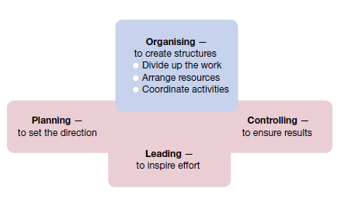

**Fig 3.4.1 Organising viewed in relationship with the other management functions**

**3.4.1 Organisational structure**

The organisational structure is the system of tasks, workflows, reporting relationships and communication channels that link the work of diverse individuals and groups. Any structure should both allocate task assignments, through a division of labour, and provide for the coordination of performance results. A good structure that does both of these things well can be an important asset to an organisation. However, there is no structure that meets the needs of all circumstances. Structure must be handled in a contingency fashion; as environments and situations change, structures must often be changed too. To make good choices, a manager must know the alternatives and be familiar with current trends and developments. They must also be prepared to create ‘chaos’ to help produce innovative solutions to complex problems, when necessary. Nothing new and innovative can emerge from organising systems that are highly ordered and stable. Chaotic systems, such as revolutions and resistance, create new configurations of decision making and power.

**Formal structure**

The concept of structure is known best in the form of an **organisation chart**, which is a diagram that shows reporting relationships and the formal arrangement of work positions within an organisation. A typical organisation chart identifies various positions and job titles, as well as the lines of authority and communication between them. This is the *formal structure*, or the structure of the organisation in its official state. It represents the way the organisation is intended to function.

**Informal structure**

Behind every formal structure typically lies an **informal structure**. This is a ‘shadow’ organization made up of the unofficial, but often critical, working relationships between organisational members. If the informal structure could be drawn, it would show who talks to and interacts regularly with whom, regardless of their formal titles and relationships. The lines of the informal structure would cut across levels and move from side to side. Importantly, no organisation can be fully understood without first gaining insight into the informal structure, as well as the formal one. Informal structures can be very helpful in getting needed work accomplished in any organisation.

Through the emergent and spontaneous relationships of informal structures, people gain access to interpersonal networks of emotional support and friendship that satisfy important social needs. They also benefit in task performance, by being in personal contact with others who can help them get things done when necessary. *Informal learning* is increasingly recognized as an important resource for organisational development. Of course, informal structures also have potential disadvantages. Because they exist outside the formal authority system, the activities of informal structures can sometimes work against the best interests of the organisation as a whole. They can also be susceptible to rumour, carry inaccurate information, breed resistance to change and even divert work efforts from important objectives.

**3.4.2 Traditional organisation structures**

A traditional principle of organising is that performance gains are possible when people are allowed to specialise and become experts in specific jobs or tasks. Given this division of labour, however, decisions must then be made on how to group work positions into formal teams or departments, and then link them together in a coordinated fashion within the larger organisation. These decisions involve a process called **departmentalisation**, which has traditionally resulted in three major types of organisation structures — the functional, divisional and matrix structures.

**Functional structures**

In **functional structures**, people with similar skills and performing similar tasks are formally grouped together into work units. Members of functional departments share technical expertise, interests and responsibilities. The first example in figure shows a common functional structure in a business. In this case, senior management includes the functions of marketing, finance, production and human resources. In this functional structure, manufacturing problems are the responsibility of the production director; marketing problems are the province of the marketing director, and so on.

The key point is that members of each function work within their areas of expertise. If each function works properly, the expectation is that the business will operate successfully. Functional structures are not limited to businesses. The figure also shows how this form of departmentalization can be used in other types of organisations, such as banks and hospitals. These types of structures typically work well for small organisations that produce only one or a few products or services. They also tend to work best in relatively stable environments, where problems are predictable and there are limited demands for innovation and change.

The major *advantages of functional structures* include the following:

* Economies of scale with efficient use of resources
* Task assignments consistent with expertise and training
* High quality technical problem‐solving
* Indepth training and skill development within functions
* Clear career paths within functions.

There are also potential *disadvantages of functional structures*. Common problems with functional structures involve difficulties in pinpointing responsibilities for things like cost containment, product or service quality, timeliness and innovation in response to environmental changes. Such problems with functional structures are magnified as organisations grow in size and environments begin to change. Another significant concern is often called the *functional chimneys problem,* refers to the lack of communication, coordination and problem solving across functions.

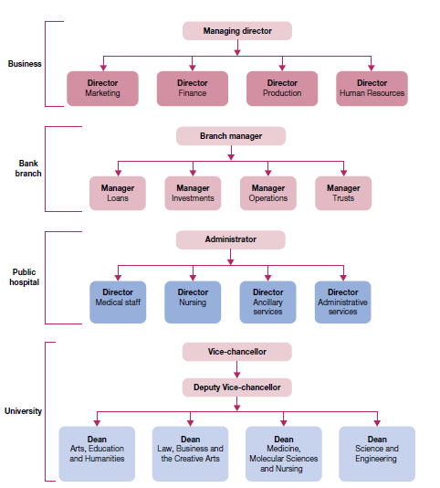

**Fig 3.4.2 Functional structures in a business, a bank branch, a public hospital and a university**

**Divisional structures**

**Divisional structure** groups together people who work on the same product or process, serve similar customers, and/or are located in the same area or geographical region. As illustrated in figure, divisional structures are common in complex organisations that have multiple and differentiated products and services, serve diverse customers, pursue diversified strategies, and/or operate in various and different competitive environments. The major types of divisional approaches are the product, geographical, customer and process structures.

Divisional structures attempt to avoid problems common to functional structures. They are especially popular among organisations with diverse operations that extend across many products, territories, customers and work processes.

The potential *advantages of divisional structures* include:

* More flexibility in responding to environmental changes
* Improved coordination across functional departments
* Clear points of responsibility for product or service delivery
* Expertise focused on specific customers, products and regions
* Greater ease in changing size by adding or deleting divisions.

There are also potential *disadvantages of divisional structures*. They can reduce economies of scale and increase costs, through the duplication of resources and efforts across divisions. They can also create unhealthy rivalries — as divisions compete for resources and attention, and they emphasise division needs and goals to the detriment of the goals of the organisation as a whole.

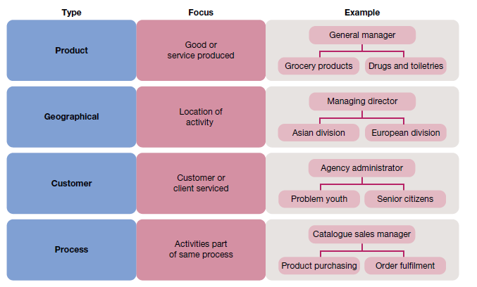

**Fig 3.4.3 Divisional structures based on product, geography, customer and process**

**Product structures**

**Product structures** group together jobs and people working on a single product or service. They clearly identify costs, profits, problems and successes in a market area with a central point of accountability. Consequently, managers are encouraged to be responsive to changing market demands and customer tastes. Common in large organisations, product structures may even extend into global operations. Product structures are becoming less common in major companies, as many companies are constantly trying to innovate and create new products. Heinz, Intel and Apple have all moved away from product structures in recent years.

**Geographical structures**

**Geographical structures** group together jobs and activities being performed in the same location or geographical region. They are typically used when there is a need to differentiate products or services in various locations, such as in different regions of a country. They are also quite common in international operations, where they help to focus attention on the unique cultures and requirements of particular regions

**Customer structures**

**Customer structures** group together people and jobs that are serving the same customers or clients. The major appeal is the ability to serve the special needs of the different customer groups. With increasing differentiation of global markets, this structure is often well suited to complex businesses.

**Process structures**

A *work process* is a group of tasks related to one another that collectively create something of value to a customer. An example is order fulfilment — when you email a catalogue retailer and request a particular item. The process of order fulfilment takes the order from point of initiation by the customer to point of fulfilment by a delivered order. **Process structures** group together jobs and activities that are part of the same processes. In the example in figure , this might take the form of product purchasing teams, order fulfilment teams and systems‐support teams for the mail‐order catalogue business.

**Matrix structures**

The **matrix structure**, often called the *matrix organisation*, combines the functional and divisional structures, it is an attempt to gain the advantages and minimise the disadvantages of each. This is accomplished in the matrix by using permanent cross‐functional teams to integrate functional expertise, in support of a clear divisional focus on a product, project or program. As shown figure, workers in a matrix structure belong to at least two formal groups at the same time — a functional group and a product, program or project team. They also report to two bosses — one within the function and the other within the team.

The matrix organisation has gained a strong foothold in the workplace, with applications in diverse settings, such as manufacturing (e.g. aerospace, electronics, pharmaceuticals), service industries (e.g. banking, brokerage, retailing), professional fields (e.g. accounting, advertising, law) and the not for profit sector (e.g. city, state and federal agencies; hospitals; universities). Matrix structures are also in multinational organisations, in which they offer the flexibility to deal with both regional differences and multiple product, program or project needs. Matrix structures are common in organisations pursuing growth strategies in dynamic and complex environments.

The main contribution of matrix structures to organisational performance lies in the use of permanent cross functional teams. Team members work closely together, and in a timely manner, to share expertise and information to solve problems. The potential *advantages of matrix structures* include:

* Better inter functional cooperation in operations and problem solving
* Increased flexibility in adding, removing and/or changing operations to meet changing demands
* Better customer service, since there is always a program, product or project manager informed and available to answer questions
* Better performance accountability through the program, product or project managers
* Improved decision‐making, as problem‐solving takes place at the team level — where the best information is available
* Improved strategic management, since top managers are freed from unnecessary problem solving and can focus on strategic issues.

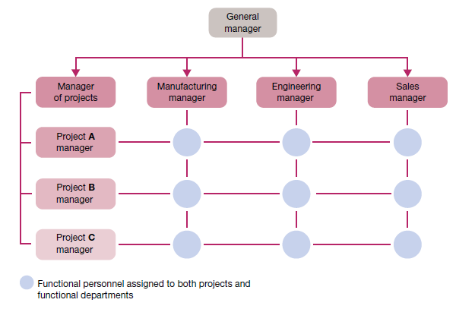

**Fig 3.4.4 Matrix structure in a small multi project business**

There are also potential *disadvantages of matrix structures*. The two‐boss system is susceptible to power struggles, as functional supervisors and team leaders vie with one another to exercise authority. The two‐boss system can also be frustrating for matrix members, if it creates task confusion and conflicts in work priorities. Team meetings in the matrix are also time consuming. Teams may develop ‘groupitis’, or strong team loyalties that cause a loss of focus on larger organizational goals, and the requirements of adding the team leaders to a matrix structure can result in increased costs.